***Naan Mudhalvan***

***Phase – 3***

***E-Commerce platform with IBM cloud foundry***

***Team Members***

1. *Naranther M*
2. *Subhash M*
3. *Sham P*
4. *Vaikundaraja N*

*Problem Statement:*

Begin building the artisanal e-commerce platform on IBM Cloud Foundry.

Design the platform layout and create a database to store product information.

***Problem Description:***

You are tasked with designing and developing an artisanal e-commerce platform that connects artisanal producers and crafters with consumers who appreciate unique, handmade products. The platform aims to provide a user-friendly and secure online marketplace where artisans can showcase and sell their creations, and customers can browse, purchase, and review these products.

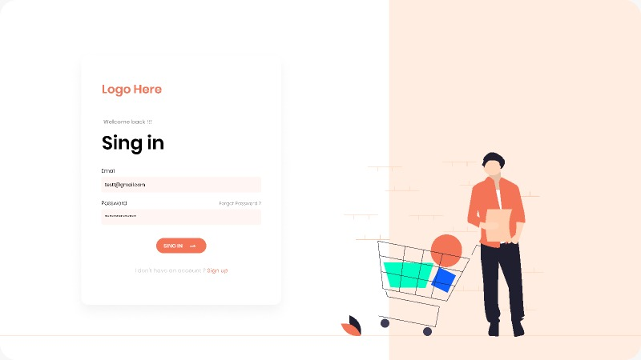

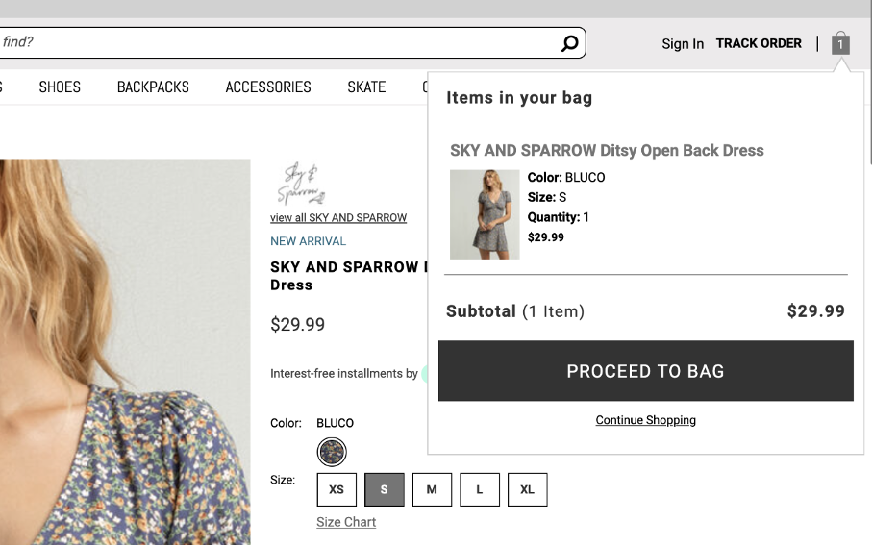

***Database to store the product information.***

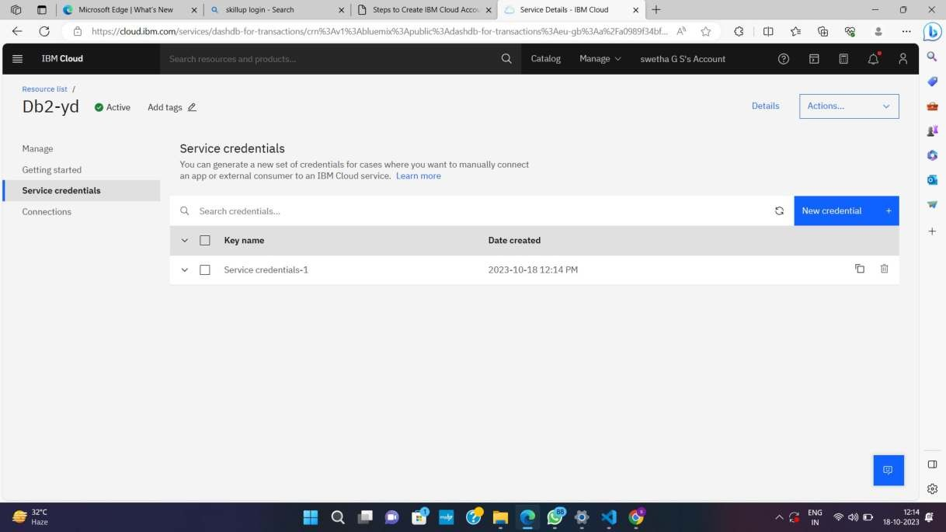

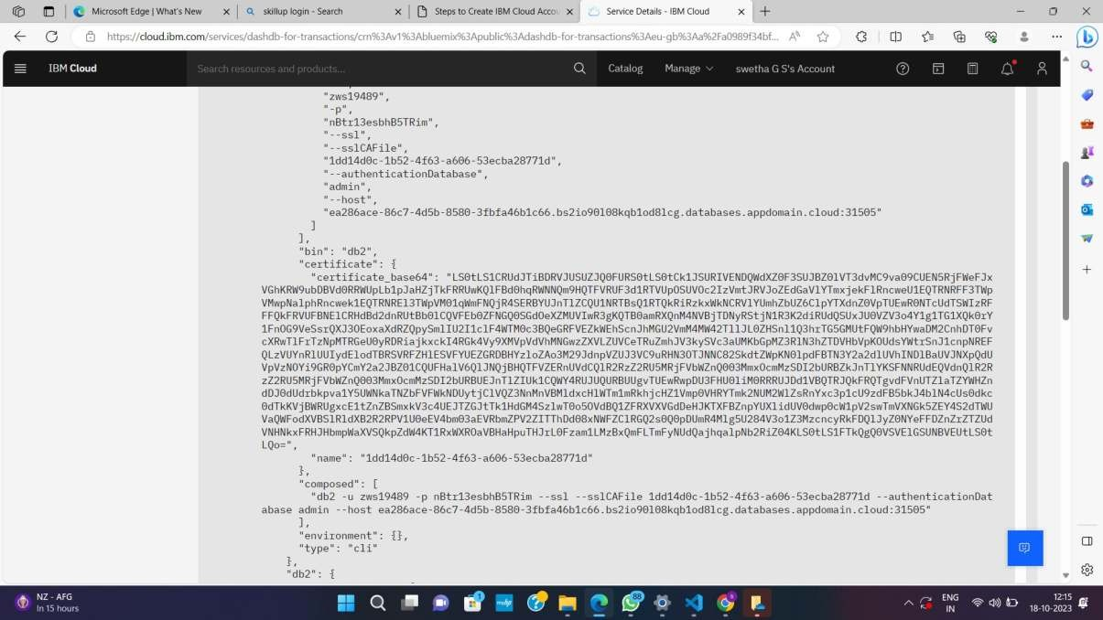

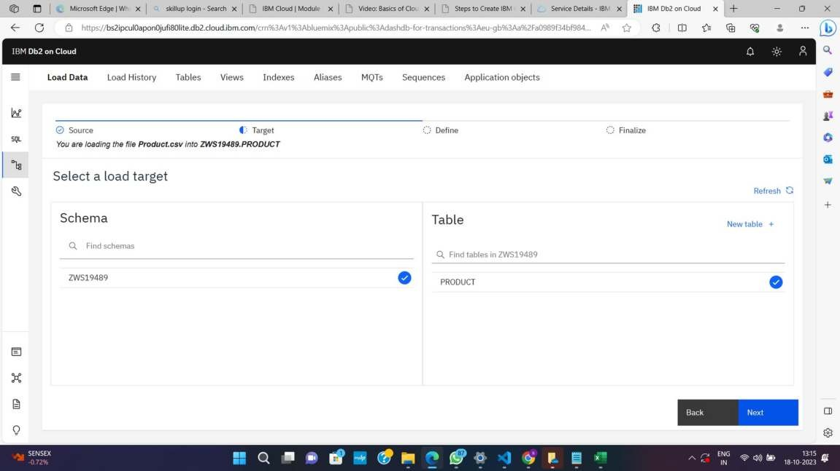

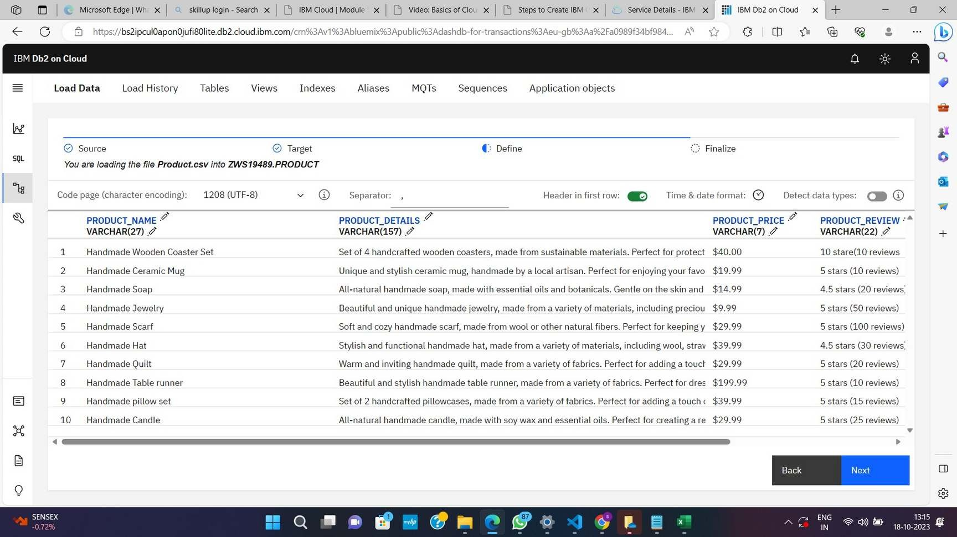

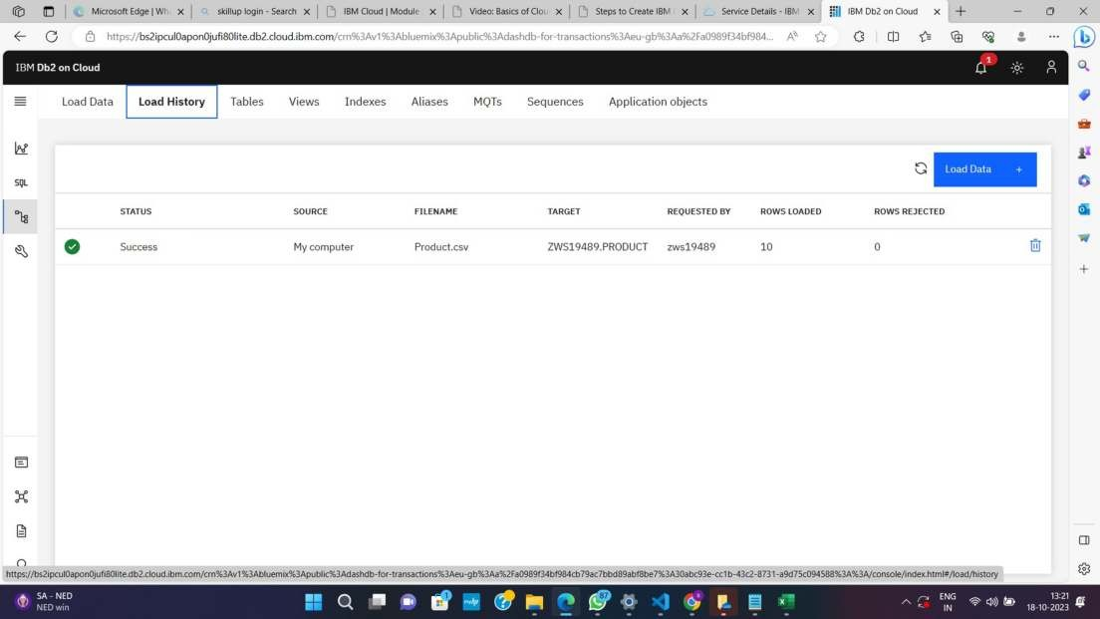

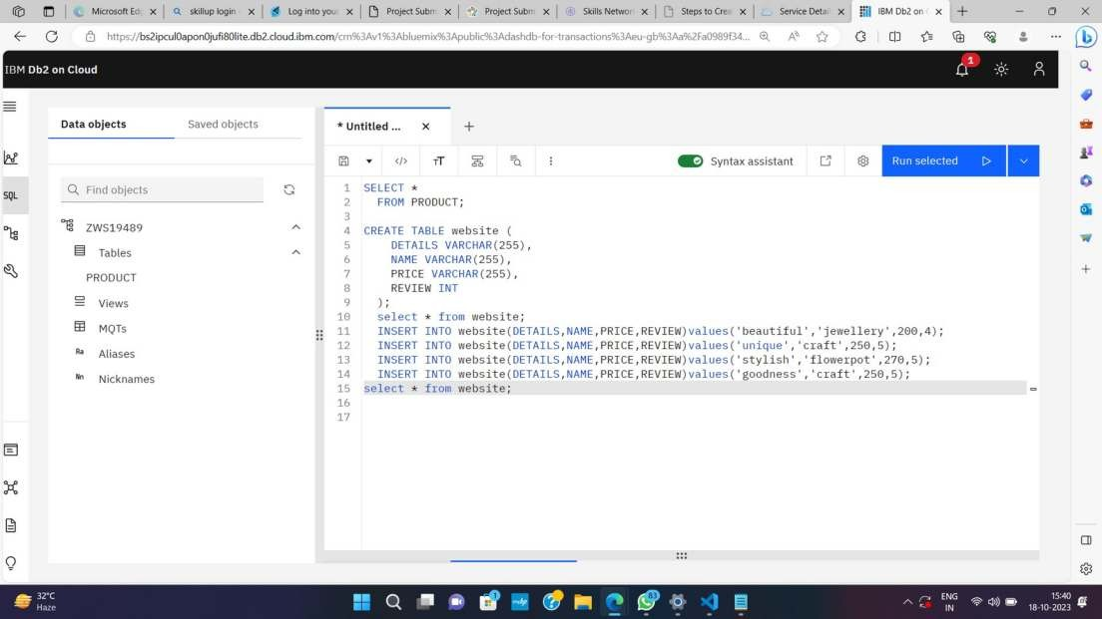

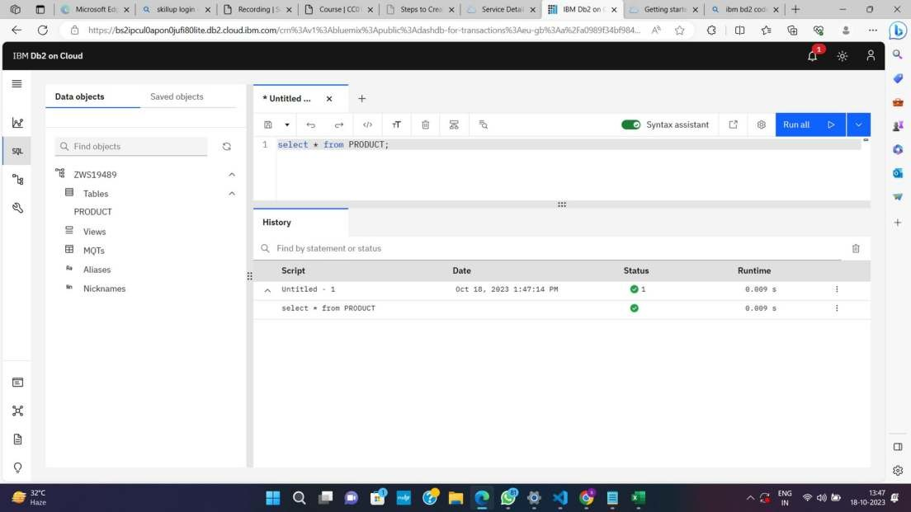

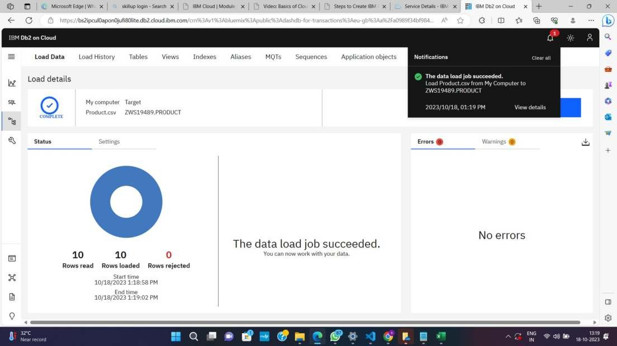

***E – Commerce Application.***

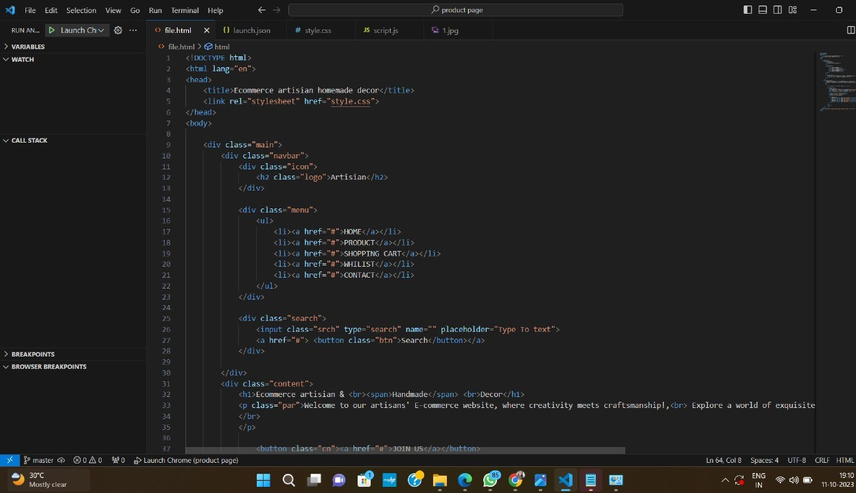

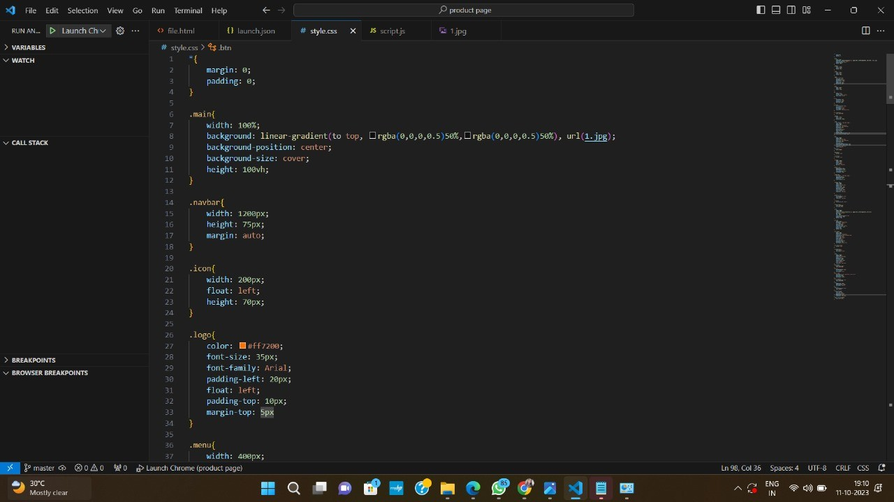

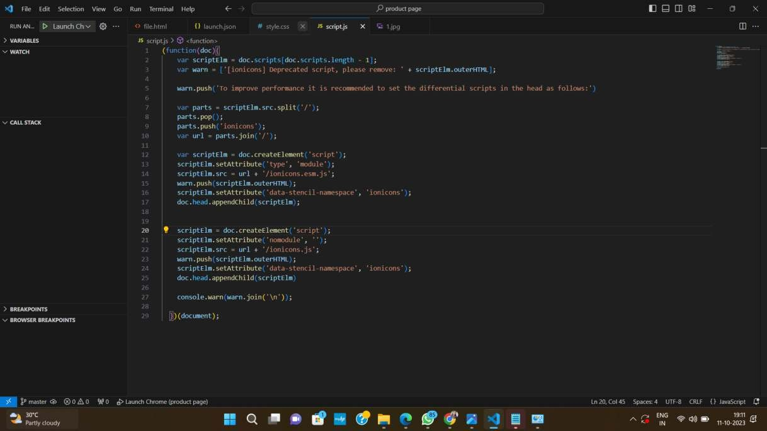

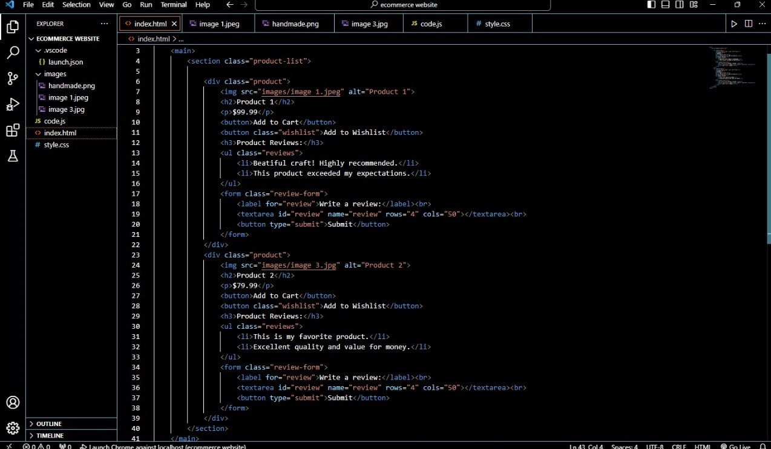

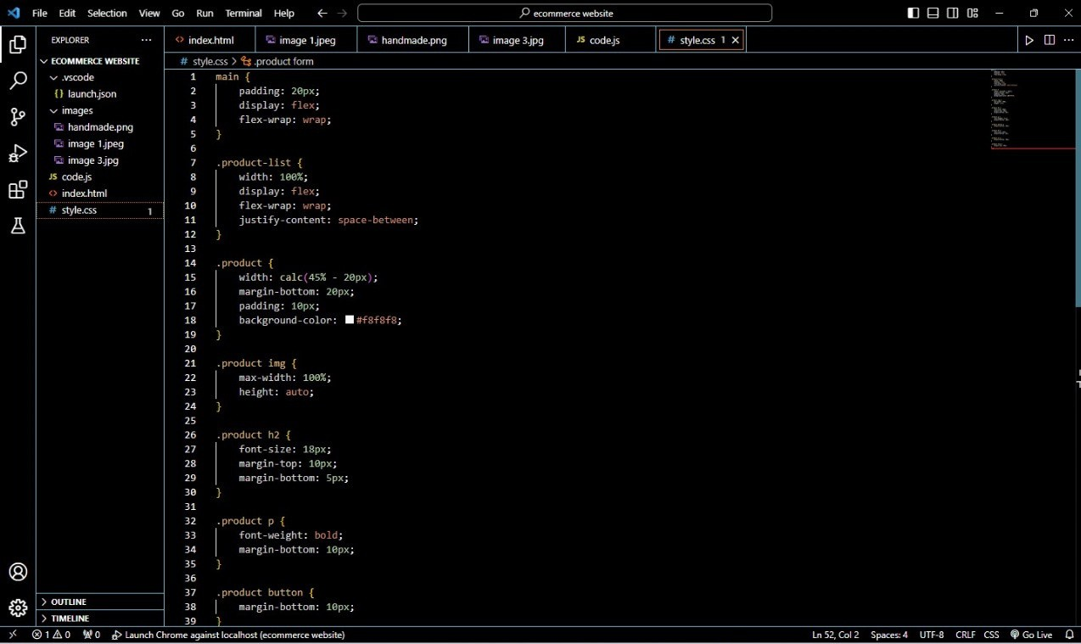

*THANKING YOU*

